IRC Solent Regional Championships 2024
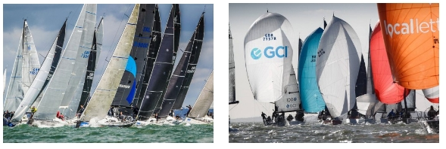
Spanning the length of the Solent this series aims to encourage IRC-rated yachts as well as cruisers in a wide range of competitive racing. Post-race hospitality at the host clubs provides the opportunity to experience the unique atmosphere of each, as well as socialising with your fellow competitors.
Royal Southern Regatta 18/19 May
Christchurch Bay Island Sailing Club 1 June
Taittinger Regatta Royal Solent YC 12/14 July
Nab Tower Island Sailing Club 7 Sept
The Championship is open to all IRC boats with a TCC between 0.750 and 1.360 and cruisers. Entry will be through the host club website, where race documentation will also be available.

Organising Committee  Solent IRC Owners Association  Email: Lois_sailing@hotmail.com  www.scra.org.iuk | 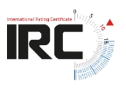 | Solent Cruising & Racing Association  Regatta House, 18 Bath Road, Cowes, Isle of Wight. PO31 7QN  Tel: 01983 295744

